**ASSIGNMENT NO 5 = TICKET BOOKING SYSTEM**

1. **CREATING A DATABASE TABLES**
2. **VENUE TABLE**

**CREATE DATABASE Ticket_System;**

**USE Ticket_System;**

**CREATE TABLE Venue (**

**venue_id INT PRIMARY KEY AUTO_INCREMENT,**

**venue_name VARCHAR(255) NOT NULL,**

**address TEXT**

**);**

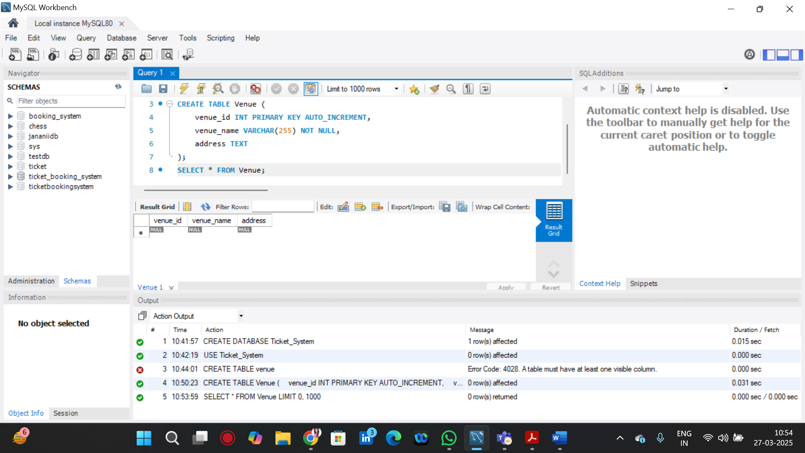

1. **EVENT TABLE**

**CREATE TABLE Event (**

**event_id INT PRIMARY KEY AUTO_INCREMENT,**

**event_name VARCHAR(255) NOT NULL,**

**event_date DATE NOT NULL,**

**event_time TIME NOT NULL,**

**venue_id INT,**

**total_seats INT NOT NULL,**

**available_seats INT NOT NULL,**

**ticket_price DECIMAL(10,2) NOT NULL,**

**event_type ENUM('Movie', 'Sports', 'Concert') NOT NULL,**

**FOREIGN KEY (venue_id) REFERENCES Venue(venue_id) ON DELETE CASCADE**

**);**

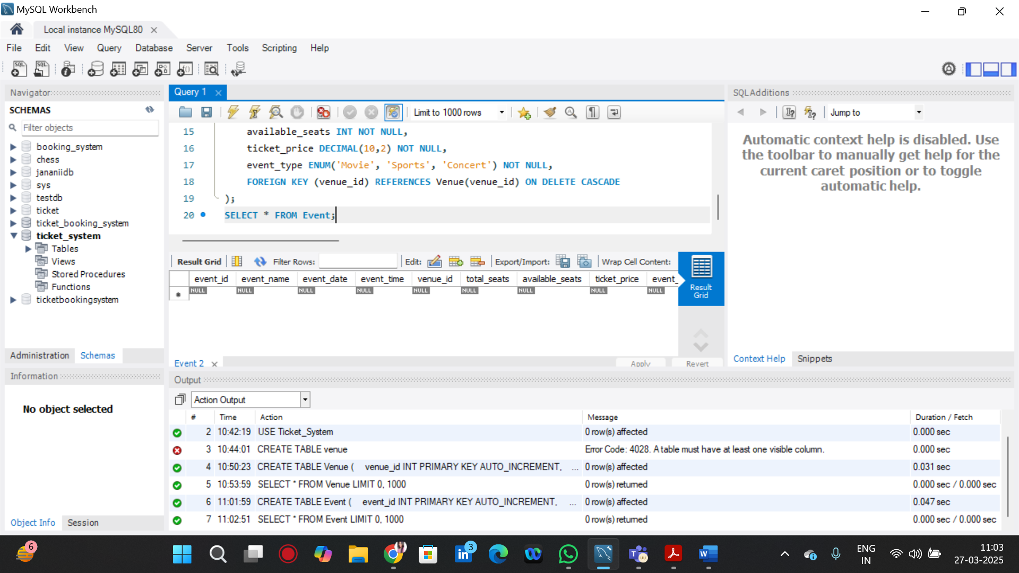

**iii)CUSTOMER TABLE**

**CREATE TABLE Customer (**

**customer_id INT PRIMARY KEY AUTO_INCREMENT,**

**customer_name VARCHAR(255) NOT NULL,**

**email VARCHAR(255) UNIQUE NOT NULL,**

**phone_number VARCHAR(15) NOT NULL**

**);**

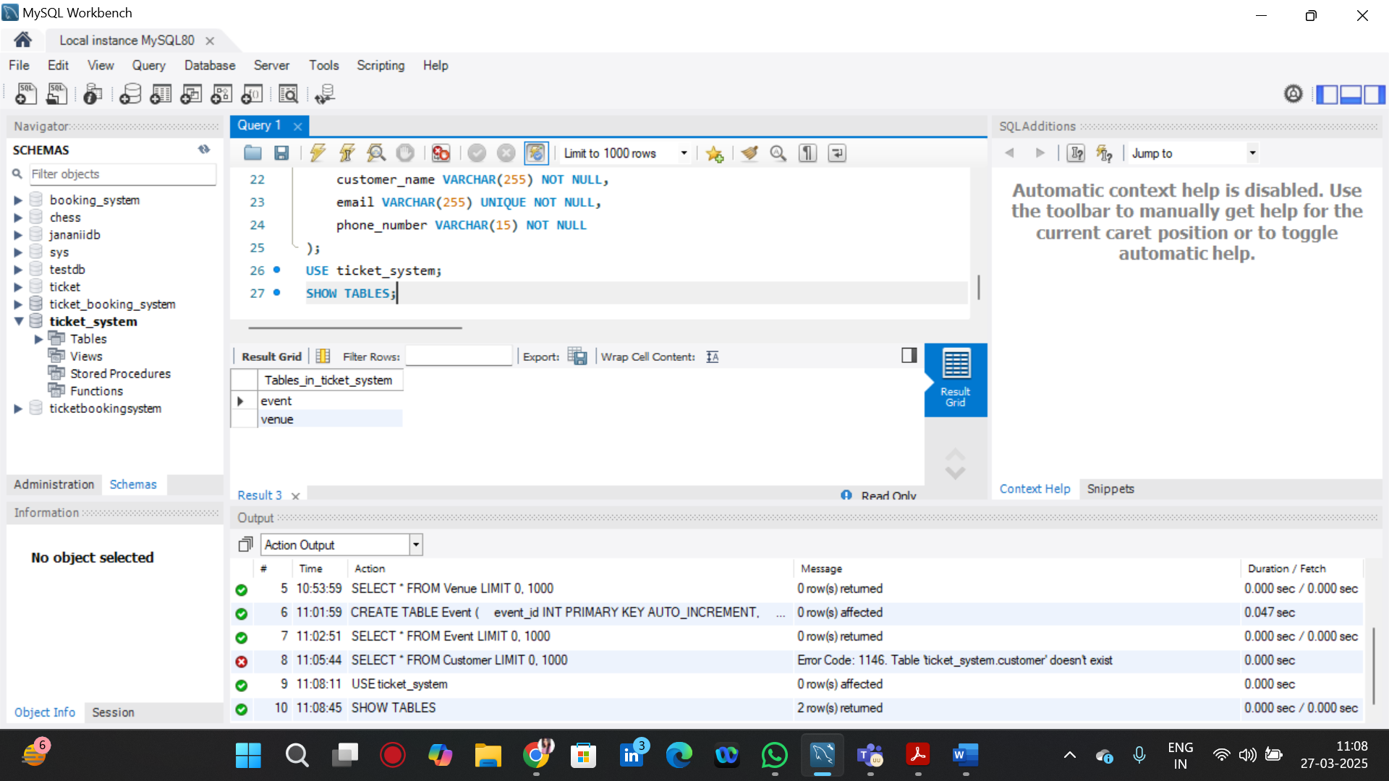

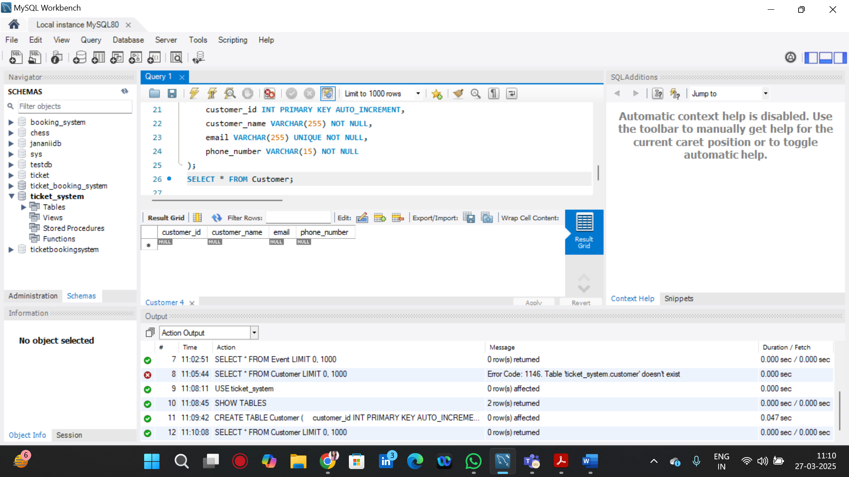

**IV) BOOKING TABLE**

**CREATE TABLE Booking (**

**booking_id INT PRIMARY KEY AUTO_INCREMENT,**

**customer_id INT,**

**event_id INT,**

**num_tickets INT NOT NULL,**

**total_cost DECIMAL(10,2) NOT NULL,**

**booking_date TIMESTAMP DEFAULT CURRENT_TIMESTAMP,**

**FOREIGN KEY (customer_id) REFERENCES Customer(customer_id) ON DELETE CASCADE,**

**FOREIGN KEY (event_id) REFERENCES Event(event_id) ON DELETE CASCADE**

**);**

